Journal of Informatics and
Web Engineering
Vol. 3 No. 3 (October 2024) eISSN: 2821-370X

Comparative analysis of the performance of CSS animation methods (transition and animation) under high DOM load
Dmitrii Zakharov¹
¹17, 138A Dolenjska Cesta, 1000 Ljubljana, Slovenia
*corresponding author: (forsocials.mail@gmail.com; ORCiD: 0009-0000-4574-1425)

Abstract - This study provides a detailed quantitative comparison of two primary CSS animation techniques – @keyframes (animations) and transitions – across a range of interface loads from 50 to 10,000 DOM elements. The objective was to assess their performance under realistic stress conditions by utilizing real-time metrics, including average frames per second (FPS), frame delta, JavaScript heap memory usage, and total animation duration. The results indicate that at low loads (50 to 2,500 elements), both techniques perform similarly in terms of frame rate, although animations tend to consume slightly more memory. At moderate loads (around 5,000 elements), animations outperform transitions in both FPS and memory usage under controlled conditions. However, at high loads (7,500 to 10,000 elements), animations exhibit a significant increase in memory usage—up to 14% more than transitions—and a marked drop in FPS when exceeding 10,000 elements. To aid in decision-making, a weighted evaluation method was applied, placing greater importance on FPS compared to memory usage. This analysis revealed that animations are 0.13% more effective overall. Conversely, when using a method of equivalent criteria, transitions showed a slight advantage of 0.03%. In absolute terms, animations utilized up to 120 MB of memory, while transitions required 80 MB. Despite this difference, the higher FPS associated with animations can offset their increased memory demands. The findings suggest that while transitions are more memory-efficient, both methods are suitable for use in modern web applications.
Keywords - css, animations, performance testing, web engineering, dom, frontend

Received: 02 July 2025; Accepted: 02 July 2025; Published: 02 July 2025
This is an open-access article under the CC BY-NC-ND 4.0 license.
- INTRODUCTION
Every day, over 250,000 new websites are registered worldwide, which translates to about 175 new sites every minute. In this competitive landscape, modern web applications must not only be functional but also highly optimized for user interface performance.

1.1 Relevance of interface optimization
Most modern web interfaces include animated elements that serve both navigation and content presentation functions. Visual effects, such as smooth transitions and animations, play a crucial role in enhancing the user experience (UX) and keeping users engaged. However, having too many animated elements running simultaneously can significantly reduce interface performance, particularly on devices with limited resources, since users expect websites to respond and load within 1 to 2 seconds, performance becomes a vital factor in the competitiveness of a web application.

1.2 Problem statement
Many widely accepted recommendations and best practices for using CSS animations and transitions are descriptive and qualitative, which makes it challenging to choose the optimal approach for developing high-load interfaces. This study aims to conduct a large-scale experimental comparison of the performance of CSS animations and transitions with varying numbers of page elements. The objective is to gather metrics that allow for a quantitative evaluation of the efficiency of each method.

1.3 Research objective
The goal of this work is to assess the quantitative performance of CSS animations and transitions using experimental data, while developing well-founded recommendations for their use in highly visually demanding interfaces.

1.4 Features of modern browsers
Modern browsers do more than render web pages; they also manage the distribution of computational resources to achieve a balance between performance and energy efficiency. To enhance performance, browsers use various techniques, one of which is partial repainting. This method updates only the changed parts of the Document Object Model (DOM) tree rather than repainting the entire screen. Another performance-boosting technique is dividing the screen into small tiles, typically measuring 256 × 256 pixels [2]. These tiles allow browsers to monitor changes and repaint only the segments where modifications occur. It is important to note that the implementation of animations and rendering can differ among browsers and operating systems. Factors such as the type of GPU, its architecture, and drivers also play a significant role. As a result, the performance of the same CSS animations can vary considerably across different platforms.
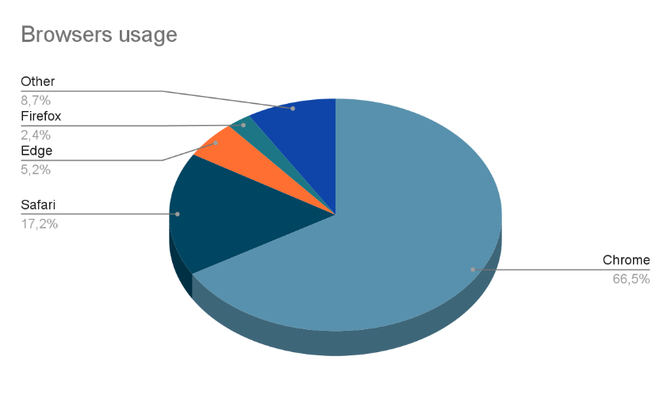
Figure 1. Comparison chart of main web browser usage shares as of May 2025
1.5 Defining the animation rendering process
After a full page load and initial rendering, modern browsers engage in a continuous cycle of interface updates and repaints. CSS animations occur within this cycle and are processed according to the browser engine's architecture. Below is a typical execution cycle of CSS animations based on Chromium’s rendering architecture [3].

1.5.1 Animation initialization (animation scheduling)
When a CSS animation or transition is applied to an element, the browser processes it by:
- Determines the properties involved in the animation.
- Generates keyframes and a timeline.
- Analyze whether the animation can be GPU-accelerated (e.g., for transform or opacity).
This step is critical for determining whether animation runs on the main thread or the compositor thread [6].

1.5.2 Compositor thread
If the animated properties permit (e.g., opacity, transform, filter), the browser hands off animation processing to the compositor thread, avoiding repainting and layout recalculation. This allows:
- Reducing the load on the main thread.
- Avoid unnecessary layout and paint operations.
- Increasing performance via GPU usage.

1.5.3 Animation update (animation tick/frame update)
For each frame iteration (usually 60fps ≈ 16.66ms per frame), the browser:
- Interpolates current animated property values.
- Updates the layer state bound to the element.
- If the element is on a GPU layer, it sends the frame to the Viz compositor.
- If repaint is required, runs the whole cycle: layout → paint → composite.

1.5.4 Visual compositing (compositing)
At the Viz compositor stage (Chromium’s compositing system), the final frame is assembled by combining:
- Visual elements of the current page.
- Elements from other processes (e.g., iframes, ads).
- Browser UI elements.
The final composited frame is sent to the GPU for display.

1.5.5 Animation completion
At the end of the animation timeline, the element achieves its final CSS property values, and events such as animationend or transitionend are triggered. This process underscores the importance of choosing CSS properties that are optimized for the GPU. For example, properties like transform and opacity can be processed entirely by the GPU, allowing them to bypass the main thread. In contrast, properties such as width, height, or left require complete recalculations of the DOM and styles, which can significantly impact performance.

- RELATED WORK
The performance of web animations is a topic of active discussion in professional circles; however, few academic studies quantitatively compare CSS transition and animation methods. Most of the existing sources are applied and are presented as articles on technical blogs (such as CSS-Tricks, Smashing Magazine, and MDN Web Docs). These articles typically provide usage recommendations without rigorous empirical validation. Works related to general web interface performance optimization discuss aspects such as the impact of DOM operations on rendering [1], GPU acceleration usage, and repaint/reflow optimization [2]. However, these rarely focus on comparing animation methods under high load. Some researchers analyze the effect of specific CSS properties on performance (e.g., transform and opacity, as they are GPU-friendly). Still, such studies typically test on small numbers of elements and do not consider the massive scenarios common to modern interfaces [7]. Thus, there is a clear gap in the systematic, large-scale comparison of transition and animation methods from a performance standpoint. This study seeks to address that gap through quantitative metrics and repeatable tests in real browsers.

- RESEARCH METHODOLOGY
To evaluate the rendering performance of various CSS animation techniques, a Single-Page Application (SPA) was designed and developed. The main objective of this SPA was to simulate high-load scenarios involving thousands of animated DOM elements, enabling a controlled comparison between two commonly used CSS methods: @keyframes (animations) and transitions. The goal was to measure key performance indicators, such as frames per second (FPS), frame stability (delta), and JavaScript heap memory consumption as the load increased.
The experimental setup was focused on isolating rendering performance from other browser overheads, such as I/O and network latency. This approach ensured that any differences in performance metrics could be specifically attributed to the animation method employed.
The technology stack was selected for its performance observability, reactivity, and ability to support detailed state and data tracking. The following components were utilized:
- JavaScript Native API: This was employed for direct access to performance-related data, including memory usage (using performance.memory), frame timings (via requestAnimationFrame), and high-resolution timestamps (with performance.now()).
- Vue.js: A reactive frontend framework used to build the Single Page Application (SPA) interface and manage the lifecycle events of DOM elements. Vue’s declarative rendering model and efficient virtual DOM make it well-suited for performance-sensitive applications [3].
- Pinia: A modern and lightweight state management library integrated with Vue, used for storing test parameters (such as selected animation type and the number of blocks) while capturing real-time updates of performance metrics. Its reactive system allowed for synchronization of data collection with rendering cycles [4].
- VueUse: A utility library that enhances Vue's Composition API with performance-related hooks. The following utilities were utilized: useFps – measures real-time and minimum frames per second (FPS) throughout the animation lifecycle; useMemory – tracks current JavaScript heap usage, allowing for monitoring of memory allocation growth during test runs; useRafFn – registers a requestAnimationFrame loop that calculates per-frame time deltas and executes metric update callbacks right at the start of each frame [5].
All collected data was persistently stored in reactive stores and synchronized across the component tree. This architecture ensured data consistency while minimizing any overhead that could interfere with measurement accuracy. Additionally, the app was designed to avoid layout thrashing and forced reflows, which can distort FPS measurements. Elements were styled using hardware-accelerated CSS properties (such as `transform` and `opacity`) to simulate real-world UI animation patterns.

- EXPERIMENTAL SETUP
Each test was structured to ensure repeatability, minimize external interference, and provide consistent performance metrics across different scenarios. The experimental setup simulated real-world conditions for CSS animations at various levels of DOM complexity.
The test workflow followed these steps:
- Element count selection – a specific number of DOM elements, were selected, ranging from 50 to 10,000. The fixed values included: 50, 250, 500, 1,000, 2,500, 5,000, 7,500, and 10,000 elements.
- Animation configuration – for each run, we chose the animation type, which was either CSS animation or transition. Additionally, a target CSS property was selected from a predefined set that included opacity, transform, filter: blur(), and background-color.
- Pre-rendering phase – all DOM elements were created and rendered before the animation began. This step was crucial for eliminating noise from layout calculations, DOM initialization, and style recalculations. It ensured that only animation-related performance was measured.
- Animation execution and data collection – after a 5-second countdown to allow browser and rendering processes to stabilize, all animations were triggered simultaneously. Each element performed the same 10-second animation. During the animation, metrics were collected every 50 milliseconds, including: average frames per second (FPS) during the animation run, time difference (delta frame) between frames to assess frame stability, JavaScript heap memory usage to track memory activity, and total animation duration.
- Repetition for accuracy – each test scenario was executed 50 times. The results were averaged to mitigate the effects of garbage collection, OS scheduling, and fluctuations in the rendering thread. Each individual test run took approximately 15 to 25 seconds, depending on the number of elements.
Tests were conducted using the latest stable versions of Google Chrome and Mozilla Firefox on a machine running Windows 11 Pro. GPU profiling confirmed that animations involving transform, opacity, and blur were offloaded to the GPU, while others remained on the main thread. These architectural distinctions were taken into account when interpreting the results.
The SPA-based test environment supported dynamic rendering, synchronized animation triggering, and real-time metric logging, providing a consistent and extensible framework for performance analysis under controlled conditions.
The experimental application is capable of dynamically rendering between 1 and 10,000 DOM elements with active animations. The test was conducted with the following point values: 50, 250, 500, 1,000, 2,500, 5,000, 7,500, and 10,000 animated blocks. Each block executes the same 10-second CSS animation. All animations start simultaneously, but the elements are pre-rendered to separate the effects of animation from the initial rendering process. Tests were performed on the latest versions of Chrome and Firefox, ensuring the relevance of the results, running on Windows 11 Pro. GPU profiling confirmed that animations utilizing the transform, opacity, and blur properties are processed on the GPU rather than the main thread. This factor was taken into consideration when interpreting the results.

- IMPLEMENTATION
This section describes the experiment implementation steps and features of the test environment used to evaluate the performance of various CSS animation methods.

5.1 Test configuration
The initial stage of testing involves configuring the environment parameters. The developed web application features a graphical interface that enables users to set up and run the test. Users can choose the type of animation (either animation or transition), specify the number of blocks to animate (ranging from 1 to 10,000), and select one of the predefined sets of animation properties (such as opacity, transform, blur, background color, etc.).
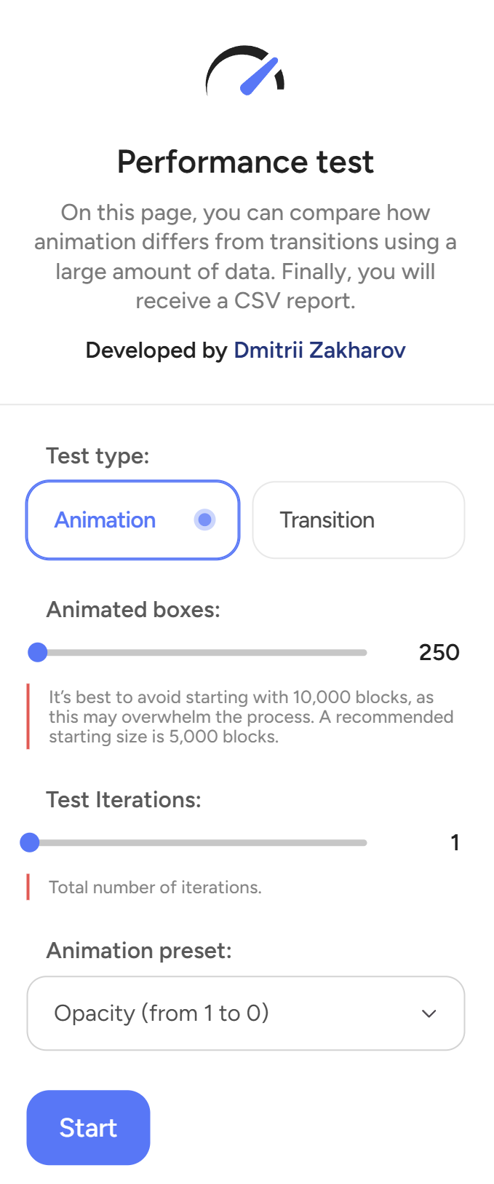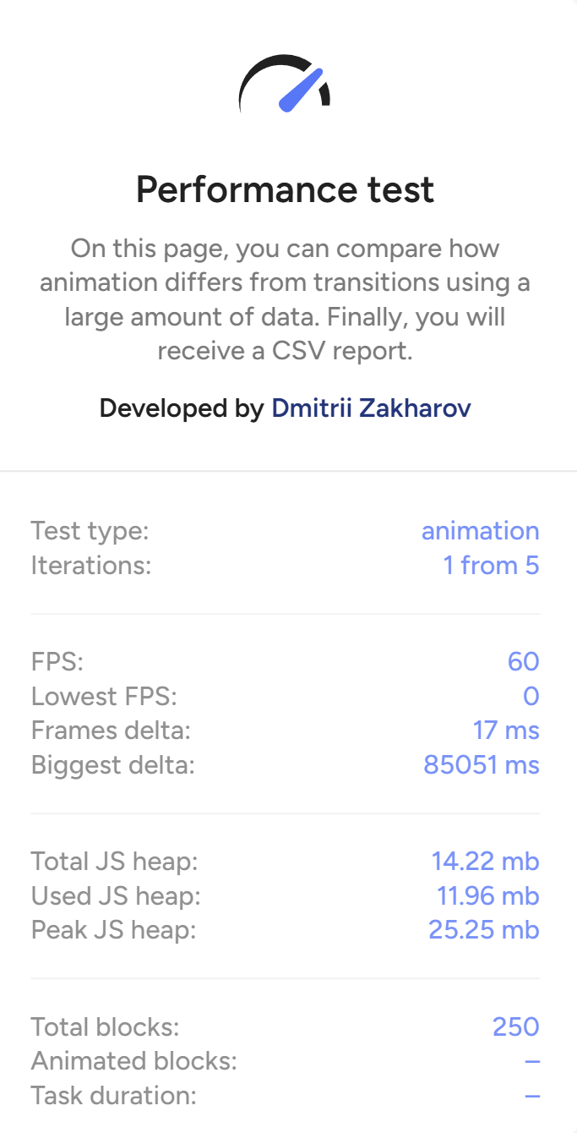
(a) | (b)
Figure 2. Graphical user interface of the load testing environment: (a) Data input stage, (b) Testing page
The interface enables flexible management of input parameters and facilitates the rapid launching of test series, ensuring that experimental conditions can be reproduced reliably.

5.2 Test execution
After configuring the settings, the user initiates the test run. During the second stage, the application enters active testing mode. At this point, each animated element is pre-rendered, and the corresponding CSS mechanism - either animation or transition - is triggered simultaneously. The graphical interface for this stage is illustrated in Figure 2.a.
Throughout the test, the system continuously monitors key browser metrics in real-time, including the current frames per second (FPS), peak JavaScript heap usage, frame delay (frame delta), and other parameters that characterize rendering performance. To measure these metrics, built-in browser APIs are called from JavaScript, along with the @vueuse/core library, which provides access to FPS and memory metrics. The collected data allows for a direct comparison of the efficiency of the two CSS animation mechanisms, based on the workload and the properties being animated during the test.

- RESULTS AND DISCUSSIONS
Test data was collected over 50 iterations during the testing phase, resulting in an average value that does not account for deviations. To mitigate the impact of outliers and distortions, the median was calculated for each data point, providing a smoother representation of the data.

  - Implementation of animated blocks: 50 units, with low complexity
This serves as a basis for establishing metrics on a minimal test set. The charts in Figure 3 illustrate the performance metrics related to CSS animations and transitions, including frame duration, frame rate (FPS), and memory usage.
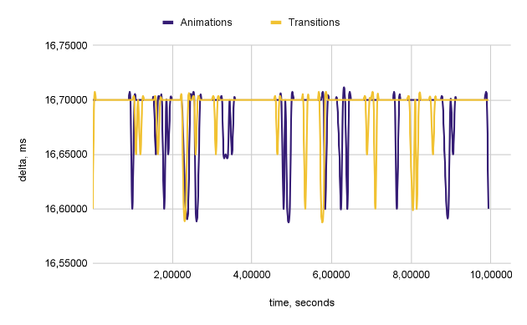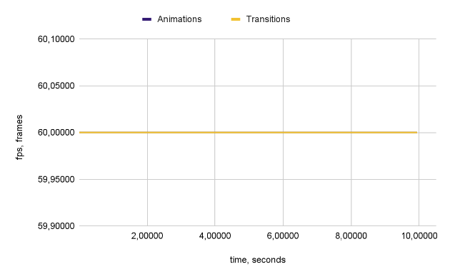
(a) | (b)
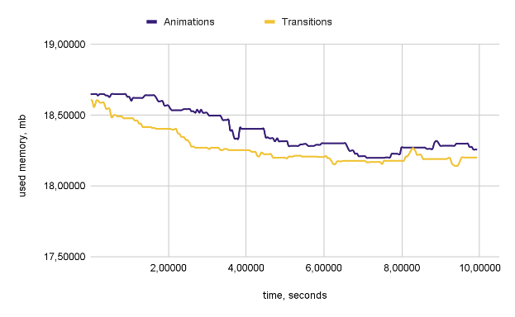
(c)
Figure 3. Performance charts for 50 blocks: (a) Frame duration, (b) FPS, and (c) Memory consumption
In the subsequent analysis, we will evaluate the performance of animations in comparison to transitions by calculating their relative value. To facilitate this assessment, we will employ Equation (1):
$$\sum_{i=1}^{N}{\frac{({mt}_{i}^{a}-{mt}_{i}^{t})}{{mt}_{i}^{a}}}$$ | (1)
Where:
- $N$ – the estimated number of iterations.
- ${mt}_{i}^{a}$ – the current metric, which can be either memory, delta, or frames per second (fps).

In terms of memory usage, the relative percentage is 0.66%, indicating that more memory is being utilized compared to the transitions. The frames per second (FPS) is currently at 0%, and the delta is -0.02%, suggesting that the FPS is lower than it was during transitions. However, overall, there is not a significant difference in FPS, as these values are close to zero. The study is continuing with a more complex data set.

  - Implementation of animated blocks: 250 units, with low complexity
The test results obtained under low-load conditions, specifically with 250 animated blocks, are analyzed. The charts illustrated in Figure 4 display the behavior of key performance metrics when using CSS animations and transitions.
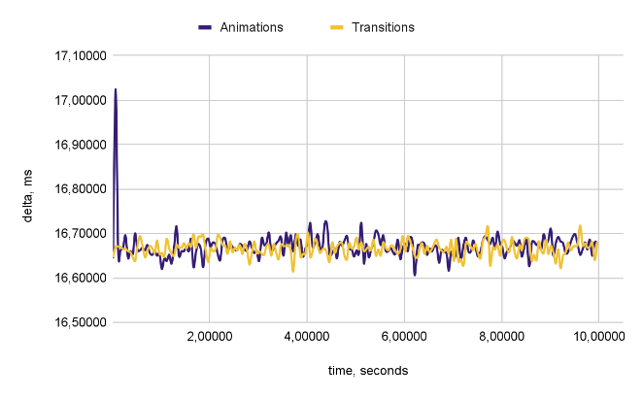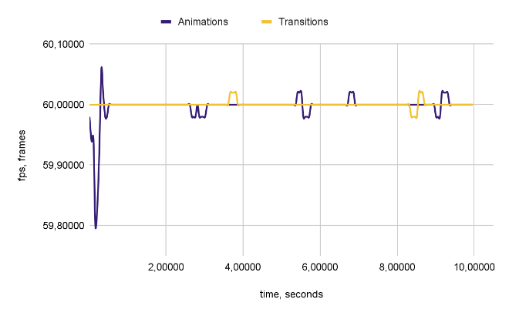
(a) | (b)
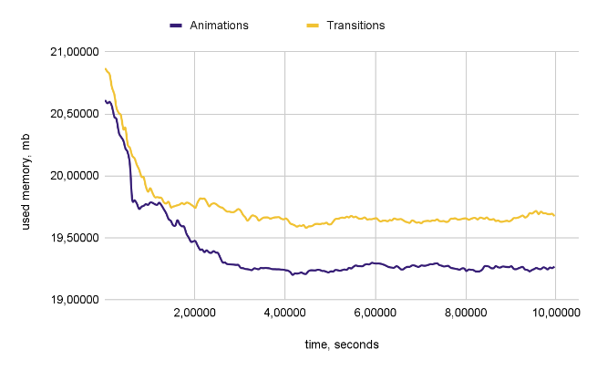
(c)
Figure 4. Performance charts for 250 blocks: (a) Frame duration, (b) FPS, and (c) Memory consumption
In terms of memory usage, the relative percentage is -1.181%, indicating that less memory is being used compared to transitions. The frames per second (FPS) is at -0.004%, with a delta of 0.02%, suggesting that the FPS is slightly lower than during the transitions. However, the overall difference in FPS is not significant, as these values are close to zero. The study is continuing with a more complex data set.

  - Implementation of animated blocks: 500 units, with low complexity.
The test results obtained under low-load conditions, specifically with 500 animated blocks, are analyzed. The charts in Figure 5 illustrate the behavior of key performance metrics when using CSS animations and transitions.
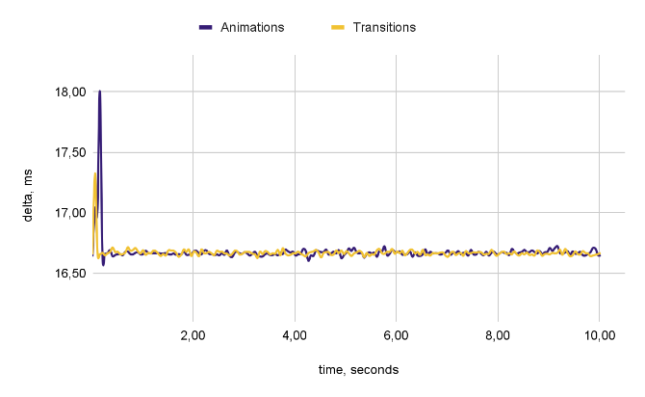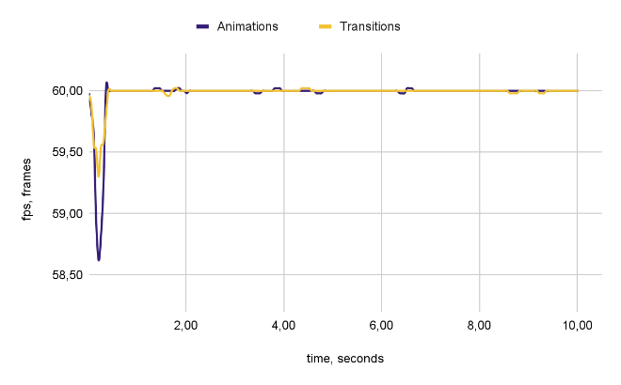
(a) | (b)
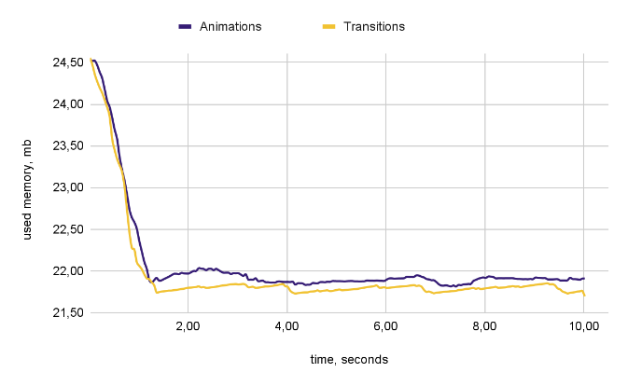
(c)
Figure 5. Performance charts for 500 blocks: (a) Frame duration, (b) FPS, and (c) Memory consumption
In terms of memory usage, the relative percentage is 0.53%, which indicates that more memory is being consumed compared to transitions. The frames per second (FPS) is currently at -0.01%, with a delta of 0.03%. This suggests that the FPS is lower during transitions. However, overall, there is not a significant difference in FPS, as these values are close to zero. The study is continuing with a more complex data set.

  - Implementation of animated blocks: 1,000 units, with low complexity.
The test results obtained under increased load conditions, specifically with 1,000 animated blocks, are analyzed. While this setup places greater demands on system resources, it still falls within a range of moderate computational complexity. The charts in Figure 6 illustrate the performance metrics for CSS animations and transitions.

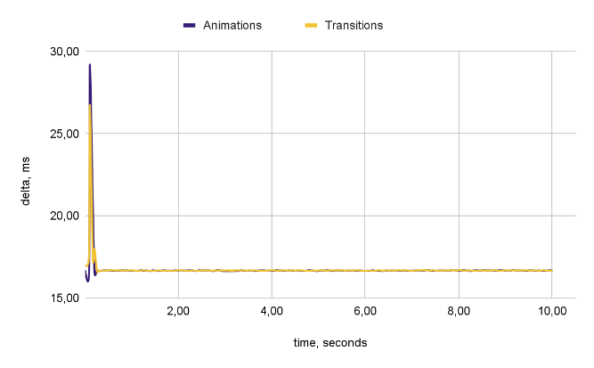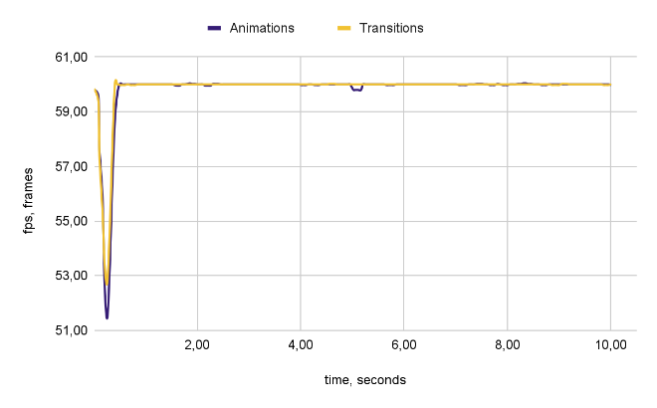
(a) | (b)
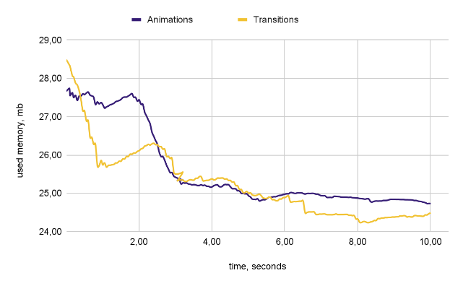
(c)
Figure 6. Performance charts for 1,000 blocks: (a) Frame duration, (b) FPS, and (c) Memory consumption

In terms of memory usage, the relative percentage is 1.40%, indicating that more memory is being utilized compared to during transitions. The frames per second (FPS) have decreased by 0.05%, and the delta shows a decline of 0.02%. This suggests that the FPS is lower than it is during transitions. However, overall, the difference in FPS is not substantial, as these values are close to zero. The study is continuing with a more complex data set.

  - Implementation of animated blocks: 2,500 units, with low complexity.
The test results obtained under increased load conditions, specifically with 2,500 animated blocks, are analyzed. This testing phase involves a more complex data set, so a slight discrepancy in the metrics is to be expected. The charts in Figure 7 illustrate the performance metrics for CSS animations and transitions.
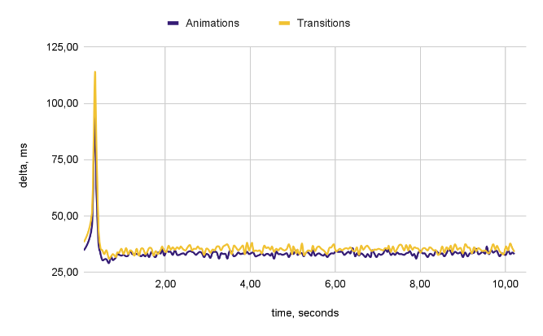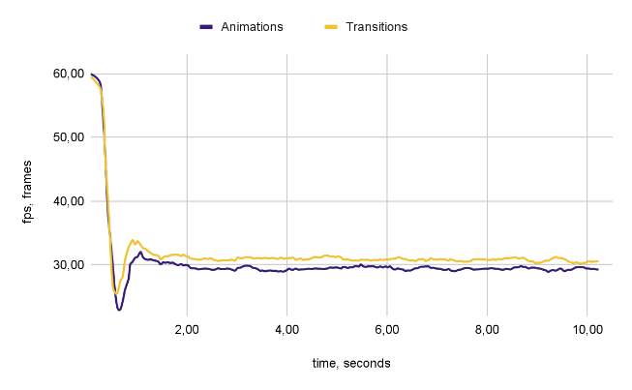
(a) | (b)
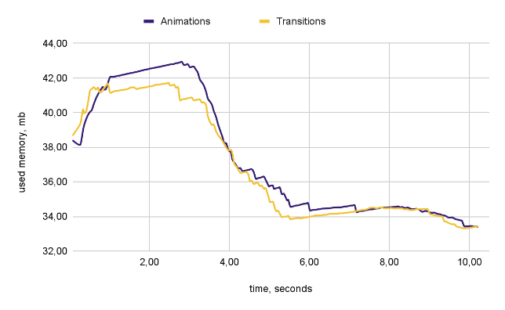
(c)
Figure 7. Performance charts for 2,500 blocks: (a) Frame duration, (b) FPS, and (c) Memory consumption
The current memory usage is at 1.23%, which indicates that more memory is being utilized compared to previous transitions. The frames per second (FPS) rate is at 4.73%, with a delta of -6.15%. This suggests that the FPS is higher during animations than during transitions.
This trend reflects both increased memory usage and improved FPS for animations. Notably, this difference is already more significant than what was observed in earlier data sets, but, as before, it cannot be the sole basis for selection.

  - Implementation of animated blocks: 5,000 units, with moderate complexity.
The test results obtained under increased load conditions, specifically with 5,000 animated blocks, are analyzed. This group of elements is anticipated to require more memory resources and will likely result in a noticeable decrease in frames per second (FPS). However, this level of performance is still considered average.
The charts in Figure 8 illustrate the performance metrics for CSS animations and transitions.
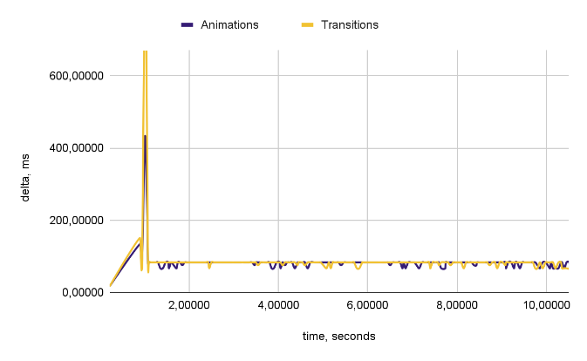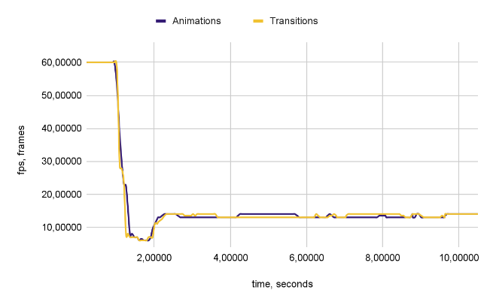
(a) | (b)
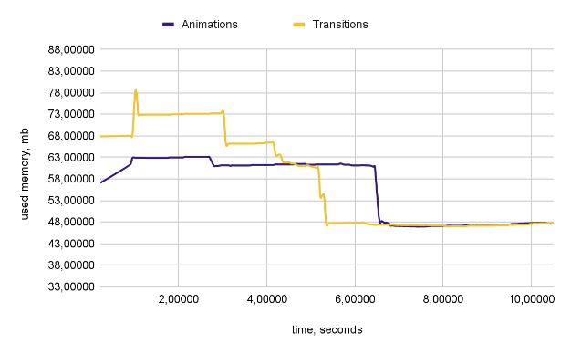
(c)
Figure 8. Performance charts for 5,000 blocks: (a) Frame duration, (b) FPS, and (c) Memory consumption

In terms of memory usage, there is a relative decrease of 1.74%, indicating that less memory is being utilized compared to the transition periods. The current frames per second (FPS) stands at 0.51%, with a change of -2.43%, suggesting that the FPS is higher than during the transitions. This reflects both reduced memory usage and improved FPS for animations. It is important to note that this situation represents ideal testing conditions, where the number of metrics remains consistent and there are no significant declines in performance.
Additionally, at this stage of testing, the amount of memory required for execution has increased from 25% to 100% at various points in time.

  - Implementation of animated blocks: 7,500 units with high complexity.
To conduct an accurate test, several complex data sets must be considered. The test results obtained under increased load conditions, specifically using 7,500 animated blocks, are analyzed. This volume of data is expected to put significant strain on system resources, leading to a more noticeable reduction in performance metrics.
The charts in Figure 9 illustrate the key metrics for CSS animations and transitions.
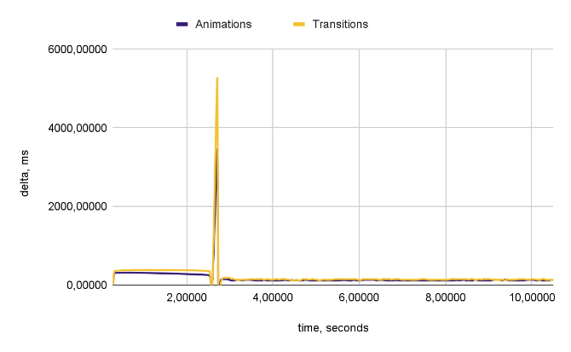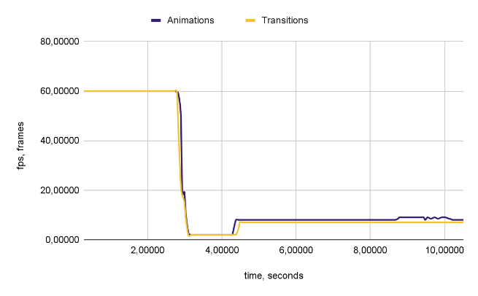
(a) | (b)
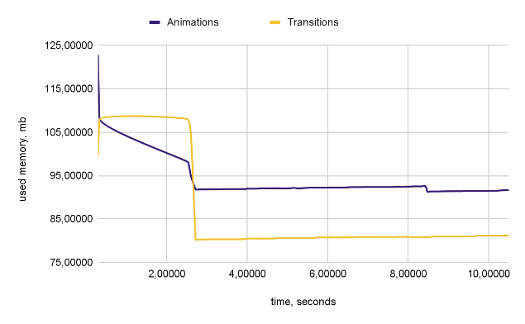
(c)
Figure 9. Performance charts for 7,500 blocks: (a) Frame duration, (b) FPS, and (c) Memory consumption

The relative percentage of memory usage has increased by 14.11%, indicating higher memory utilization compared to the transition periods. The current frames per second (FPS) stands at 12.04%, with a delta of -16.80%, suggesting that the FPS is now lower than during the transitions. This situation reflects both increased memory usage and improved FPS for animations.
It is important to note that the amount of memory required, compared to the previous test, is between 25% and 100% higher than in the earlier tests, and from 100% to 400% of the measurements taken with 2500 blocks.

  - Implementation of animated blocks: 10,000 units with high complexity.
The test results were gathered under high load conditions using 10,000 animated blocks. This is the maximum threshold for testing; exceeding this limit can result in significant metric losses due to system overload, making the outcomes subjective. It's important to note that at this level of load, there may be a loss of frames and metrics, as it is considered very demanding for the browser process. However, this test will offer valuable insights into performance differences.
The charts in Figure 10 clearly illustrate the key performance metrics for CSS animations and transitions.
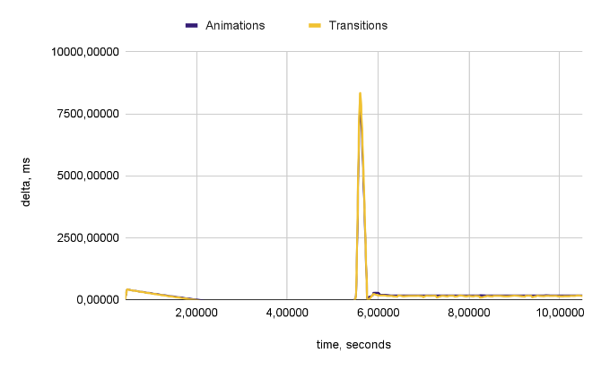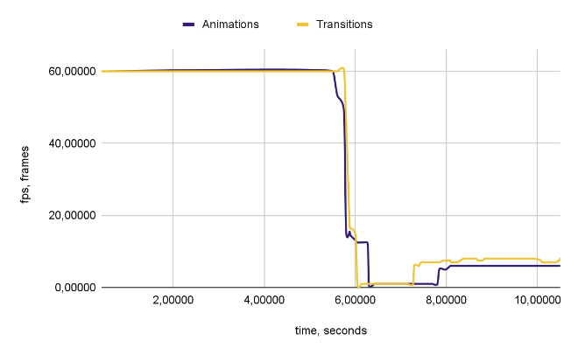
(a) | (b)
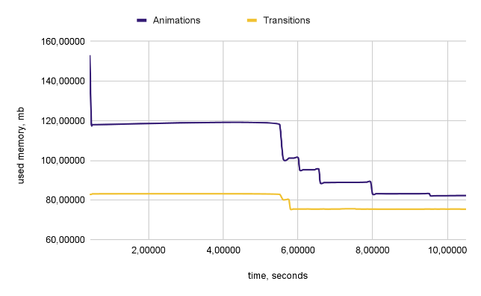
(c)
Figure 10. Performance charts for 10,000 blocks: (a) Frame duration, (b) FPS, and (c) Memory consumption
The percentage of memory usage has increased by 10.07%, indicating a higher utilization of memory compared to the transition periods. Currently, the frames per second (FPS) have decreased by 43.24%, with a change of 13.69%. This suggests that the FPS is now lower than it was during the transition phases. This situation reflects an increase in memory usage alongside a decrease in FPS for animations. While memory consumption has increased, it is not as significant as it was in previous instances.
During testing, we reduced the number of measurement points by 25% due to the large size of the dataset. However, this reduction still allows us to effectively compare both methods. All the necessary data for conducting a comparative analysis has been collected at this stage.

  - High load resistance evaluation
To compare the two methods, we introduce a measure of load resistance. The resistance column offers insight into the resistance of each method in relation to the optimal scenario, which uses 50 blocks. This metric is calculated by considering the weights [9] assigned to each aspect, as detailed in Equation (2):
$$w_{delta}=0; w_{fps}=0.70; w_{memory}=0.30$$ | (2)
Where:
- $w_{fps}$ – the weight assigned to FPS, which is set at 0.70, indicating its greater significance compared to memory usage.
- $w_{delta}$ – the weight assigned to memory usage is set to 0.30, indicating that it is less critical than FPS.
- $w_{memory}$ – the weight for FPS delta calculation is set to zero, as it is more appropriate to evaluate performance based on actual FPS rather than its fluctuations.
The resistance metric is calculated according to Equation (3):
$$R_{i}=\frac{\sum_{j=delta}^{metrics}{ w_{j}× \left(\frac{m_{j}^{i}}{m_{j}^{50}}\right) }}{w}$$ | (3)
Where:
- $R_{i}$ – high load resistance for the test with $i$ data points.
- $metrics$ – the set of evaluated metrics: delta, FPS, and memory.
- $i$ – the number of data points used in the test.
- $j$ – the current metric from the set of metrics.
- $m_{j}^{i}$ – the average value of metric $j$ for the test with $i$ data points.
- $m_{j}^{50}$ – the average value of metric $j$ in the reference scenario using 50 data points.
- $w_{j}$ – the weight assigned to metric $j$.
- $w$ – the total weight assigned to all metrics.
After receiving the initial values, they must be normalized to a range from 0 to 1. The normalized resistance metric is calculated according to Equation (4):
$$R_{i}^{n}=\frac{1}{R_{i}}$$ | (4)
Where:
- $R_{i}$ – high load resistance for the test with $i$ data points.
- $R_{i}^{n}$ – normalized value $R_{i}$ ranges from 0 to 1.
The lower the value, the less the load resistance compared to the reference values. The performance characteristics for all test cases, along with their resistance to high loads, are summarized in Table 1.
Table 1. Performance comparison of CSS animations vs transitions
 | Animations |  |  |  | Transitions
 | Delta | FPS | Memory | Resistance | Delta | FPS | Memory | Resistance
50 | 16.69 | 60.00 | 18.39 | 100.00% | 16.69 | 60.00 | 18.27 | 100.00%
250 | 16.67 | 59.99 | 19.39 | 98.47% | 16.67 | 60.00 | 19.73 | 97.75%
500 | 16.68 | 59.97 | 22.08 | 94.55% | 16.67 | 59.98 | 21.96 | 94.52%
1000 | 16.74 | 59.82 | 25.61 | 89.75% | 16.74 | 59.85 | 25.25 | 90.02%
2500 | 33.68 | 31.43 | 37.33 | 51.45% | 35.84 | 29.98 | 36.86 | 49.85%
5000 | 81.65 | 14.34 | 55.28 | 25.99% | 84.96 | 1.20 | 56.50 | 25.64%
7500 | 142.43 | 10.38 | 92.40 | 17.98% | 172.28 | 9.25 | 79.35 | 17.02%
10000 | 221.51 | 7.66 | 85.24 | 14.45% | 200.88 | 9.13 | 75.70 | 17.02%

6.10 Comparison of results
The average stability is then calculated based on all the values according to Equation (5):
$$R^{A/T}=\sum_{i=50}^{10,000}{\frac{R_{i}^{n}}{N}}$$ | (5)
Where:
- $N$ – number of received resistances.
- $A/T$ – indexes for animations and transitions.
By substituting the initial values, we calculated an average resistance of 56.09% for animations and 55.96% for transitions. These results indicate that animations perform slightly better in terms of scaling. However, the differences are minimal, suggesting that both methods can be considered equivalent within an acceptable margin of error.
It is important to note that we frequently used the median in our calculations to eliminate potential outliers. The metrics we analysed combine memory consumption and frames per second (FPS). Since we added weights for memory consumption, the results are more representative of actual performance. When excluding the weights from our metrics, animations show a resistance of 54.98%, while transitions have a resistance of 55.01%. Although this adjustment alters the results, the difference remains minimal, reinforcing the idea of the equivalence of these rendering methods.

- CONCLUSION
This study conducted a comprehensive and large-scale experimental evaluation of the performance of CSS animations and transitions under various interface loads, ranging from 50 to 10,000 animated elements. The objective was to quantitatively assess the behavior of each method regarding frame rate stability, memory usage, and responsiveness at different levels of stress. For a single test of one method, data was collected, yielding between 7,000 to 10,000 data points.
At low loads, animations and transitions exhibit similar performance in terms of frames per second (FPS), with differences typically within a few percentage points that are not statistically significant. However, animations tend to use slightly more memory even at minimal loads, and this trend becomes more pronounced as the number of elements increases. By the time there are 2,500 elements, a noticeable increase in both memory usage and FPS for animations begins to emerge.
At moderate loads of 5,000 elements, animations show improved FPS performance and lower memory usage compared to transitions. This stage represents an optimal performance point under controlled conditions, with stable metrics and no significant degradation observed.
At high loads of 7,500 to 10,000 elements, memory usage for animations increases significantly – up to 14% more than that for transitions. Additionally, FPS performance becomes more variable. At 7,500 elements, FPS remains relatively high; however, at 10,000 elements, it drops sharply, indicating diminishing returns. Nonetheless, sufficient data has been gathered to allow for a reliable comparative analysis of both approaches under heavy load.To ensure an accurate comparison while considering the significance of various criteria, we conducted an assessment based on the weighted metrics. The weights were assigned to memory and frames per second (FPS), with a higher weight given to the FPS metric, as it is deemed more indicative than memory consumption. The results showed that using these weights, the animation method is 0.13% more effective. It's important to note that the memory consumption metric was assigned smaller weights, which is why it was considered less significant than FPS. However, when evaluating using the method of equivalent criteria, the transition method proves to be 0.03% more advantageous than the animation method. In the memory consumption test, animations used 120 MB of memory, while transitions used 80 MB. Although the difference in memory usage is notable, it is not critical, as the increased frames per second (fps) for rendering compensates for the higher memory consumption.
Transitions generally use memory more efficiently than animations, which is understandable given their rendering methods. However, both approaches maintain roughly similar levels of overall memory usage. As the number of animations increases, memory consumption tends to be higher compared to transitions. Nevertheless, it would require substantial effort to reach a point where this difference becomes noticeably impactful.
From a practical standpoint, this means that while one method may have a slight advantage over the other, both approaches are acceptable for use. When implementing animations, it's important to recognize that they can consume more memory. However, as demonstrated in the 50-element data set, this difference in memory usage is generally not significant compared to transitions.

ACKNOWLEDGEMENT
The authors would like to thank the anonymous reviewers for their valuable comments.

FUNDING STATEMENT
The authors received no funding from any party for the research and publication of this article.

AUTHOR CONTRIBUTIONS
Dmitrii Zakharov: Conceptualization, Data Curation, Methodology, Validation, Writing – Original Draft Preparation;

CONFLICT OF INTERESTS
No conflict of interests were disclosed.

ETHICS STATEMENTS
This study did not involve any human participants or animals; therefore, ethical approval was not required. All experiments were conducted using software simulations and browser-based performance tests. The data presented are original and have been collected and analyzed with academic integrity. No conflicts of interest are declared by the authors. All software tools and libraries used in this research are correctly cited and utilized by their licenses.

REFERENCES
[1] Siteefy, "How Many Websites Are There in the World? (2024)", Siteefy, [Online]. Available: https://siteefy.com/how-many-websites-are-there. [Accessed: Jul. 3, 2025].
[2] Google Developers, "RenderingNG architecture", Chrome for Developers, [Online]. Available: https://developer.chrome.com/docs/chromium/renderingng-architecture?hl=ru. [Accessed: Jul. 3, 2025].
[3] StatCounter, "StatCounter Global Stats - Browser, OS, Search Engine including Mobile Usage Share", StatCounter, [Online]. Available: https://gs.statcounter.com. [Accessed: Jul. 3, 2025].
[4] Pinia, "Introduction", Pinia - Vue Store, [Online]. Available: https://pinia.vuejs.org/introduction.html. [Accessed: Jul. 3, 2025].
[5] VueUse, "Guide", VueUse Documentation, [Online]. Available: https://vueuse.org/guide. [Accessed: Jul. 3, 2025].
[6] Mozilla Contributors, "CSS Animations", MDN Web Docs, [Online]. Available: https://developer.mozilla.org/en-US/docs/Web/CSS/CSS_animations. [Accessed: Jul. 3, 2025].
[7] Google Developers, "Rendering Performance", web.dev, [Online]. Available: https://web.dev/articles/rendering-performance?hl=ru. [Accessed: Jul. 3, 2025].
[8] H. K. Lam and W. B. Lee, "User behavior modeling and analysis for online information retrieval," *IEEE Transactions on Knowledge and Data Engineering*, vol. 24, no. 4, pp. 732-744, Apr. 2012.
[9] R. L. Keeney and H. Raiffa, Decisions with Multiple Objectives: Preferences and Value Trade-Offs, Cambridge, U.K.: Cambridge University Press, 1993.

BIOGRAPHIES OF AUTHORS
 | Dmitrii Zakharov is a Staff Engineer at Sportradar, with over nine years of experience in technology, including four years in engineering leadership roles. He specializes in frontend engineering, performance optimization, scalable UI platforms, and comparative analysis of modern web development architectures. Dmitrii combines hands-on expertise with strategic vision to build scalable frontend systems and lead high-performing teams while fostering cross-functional collaboration.  His technical skills include Vue.js, Nuxt.js, React.js, TypeScript, Node.js, and GraphQL, along with experience in DevOps and CI/CD practices. Dmitrii holds a Master of Engineering (MEng) in Information Technology from Sevastopol State Technical University in Russia. He can be reached at forsocials.mail@gmail.com.

